----------

URL : http://www.greenstechnologys.com

NOTE: Print Greens Technologys Software Training Centers in Chennai

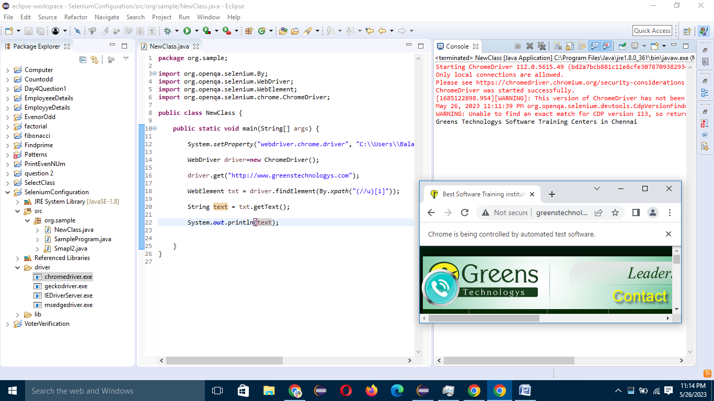

----------

URL : http://greenstech.in/selenium-course-content.html

NOTE: Print paragaraph starts with offers 200.

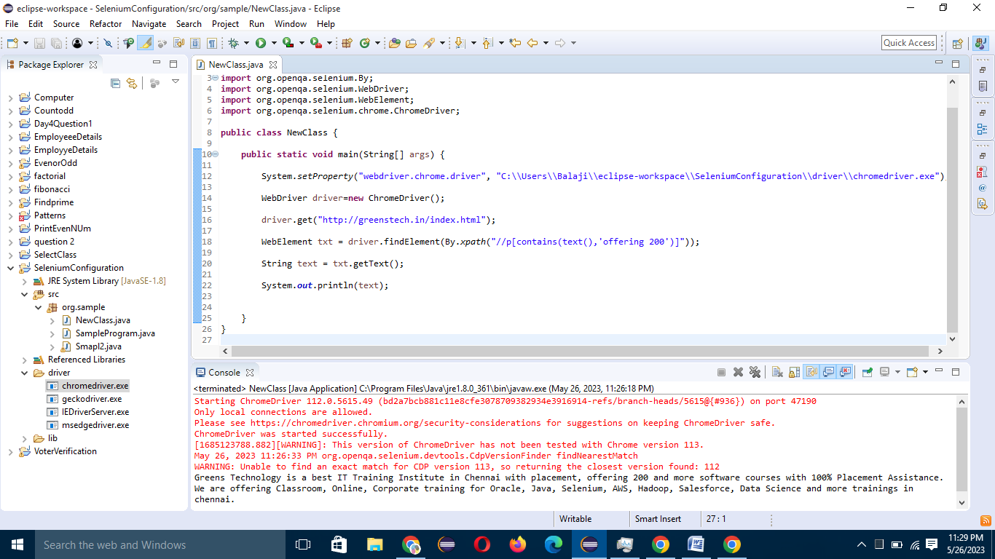

----------

URL : http://greenstech.in/selenium-course-content.html

NOTE: Print the adayar branch address

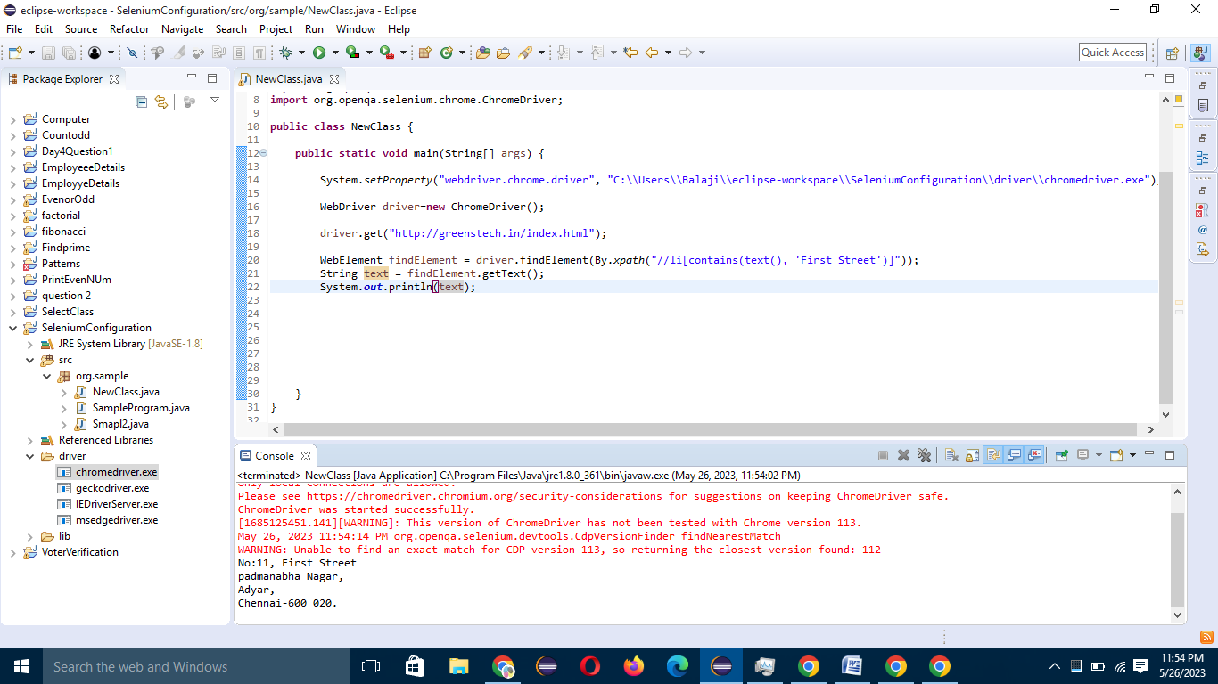

----------

URL : http://greenstech.in/selenium-course-content.html

NOTE: Print the omr branch address

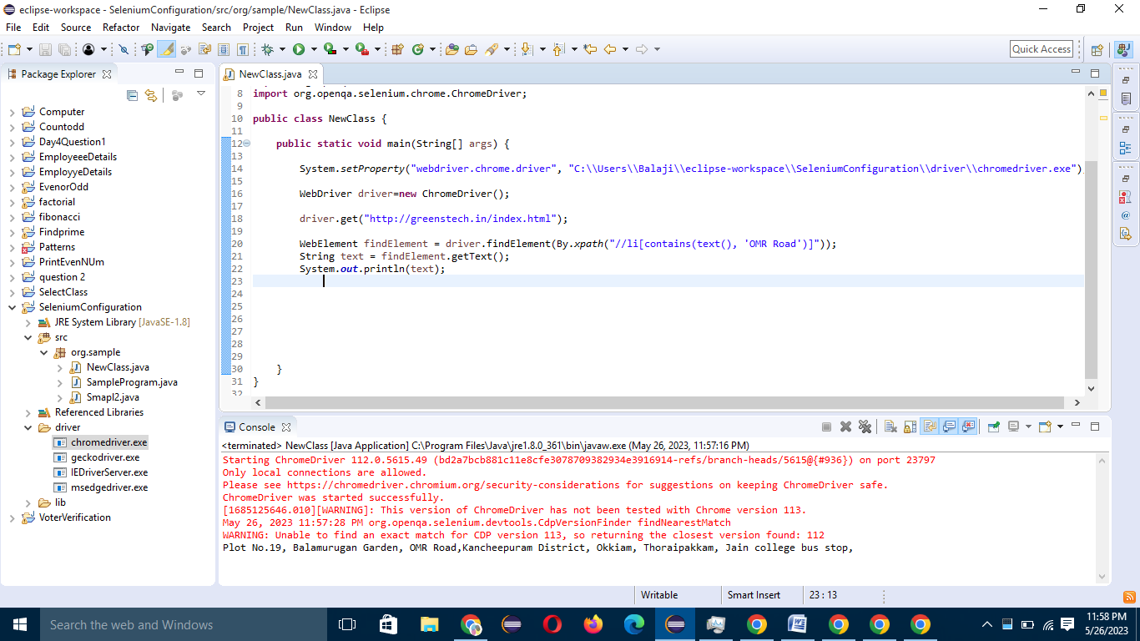

----------

URL : http://www.greenstechnologys.com/

NOTE: Print the paragraph starts with Greens Technology

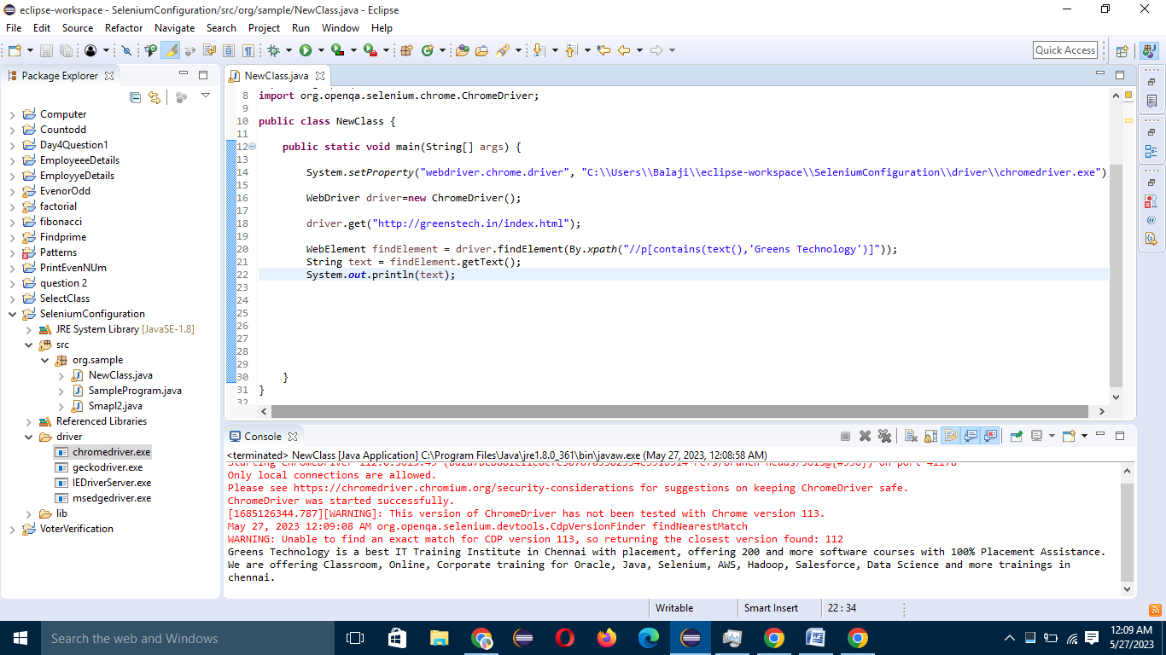

----------

URL : https://www.facebook.com/

NOTE: Print the email and password which was entered by user

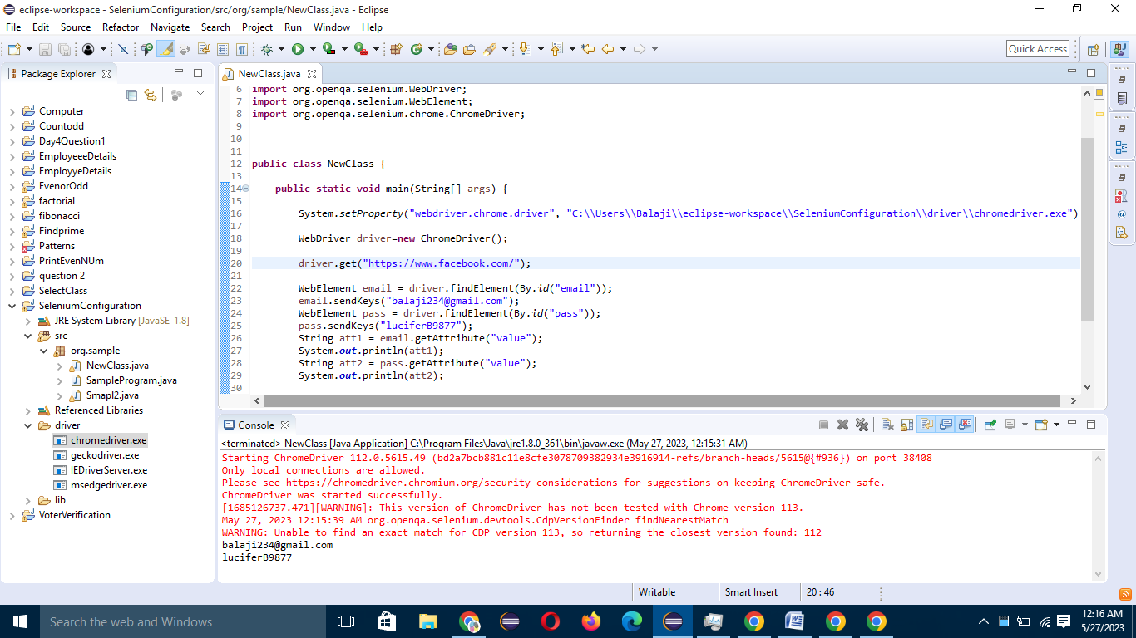

----------

URL : http://www.google.com/

NOTE: Search greens velmurugan and click the 1st link.

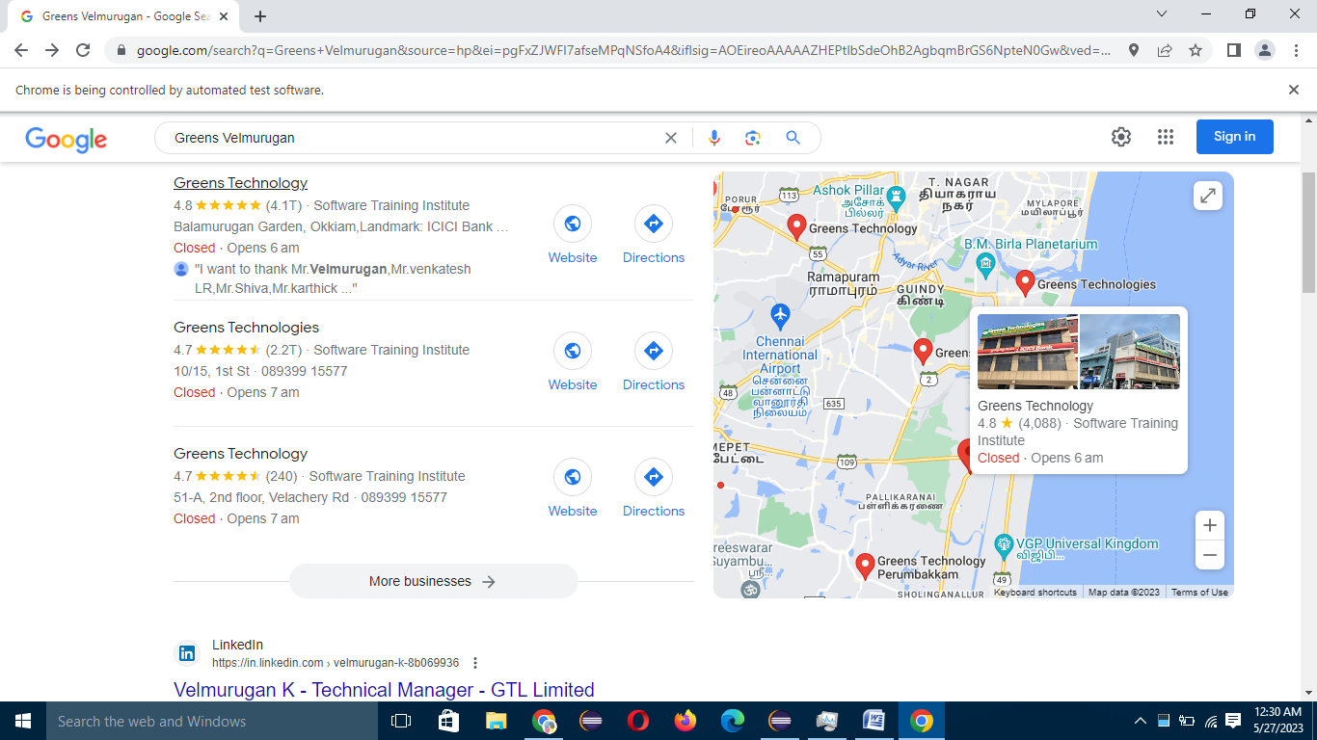

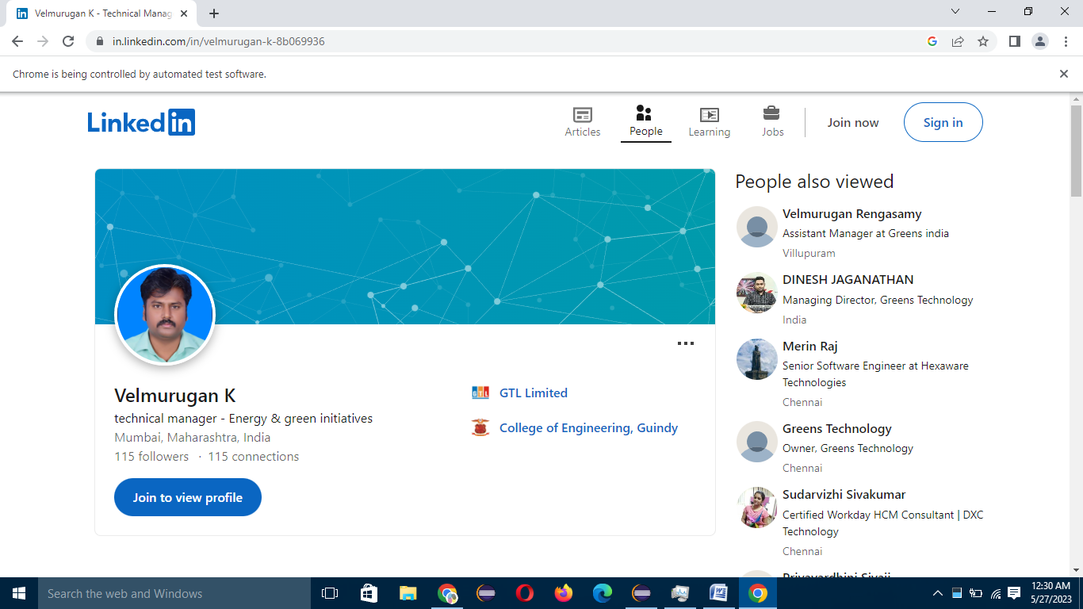

------------

URL : http://adactinhotelapp.com/

NOTE: Print the UserName and Password that you are entered.

